Epicuriousity

# Project Brief

The Epicuriousity project will analyze the epirecipes dataset found on Kaggle that contains over 20k Epicurious recipes with their ratings, categories and nutritional information. We will use this dataset to understand the popularity of recipes in relation to nutritional information, number of ingredients and categories.

# Project Members

Amy Koldeway, Sarah Cross, Alli Vaughn

# Data Set

Link to dataset: <https://www.kaggle.com/hugodarwood/epirecipes>

# Inspiring Viz’s

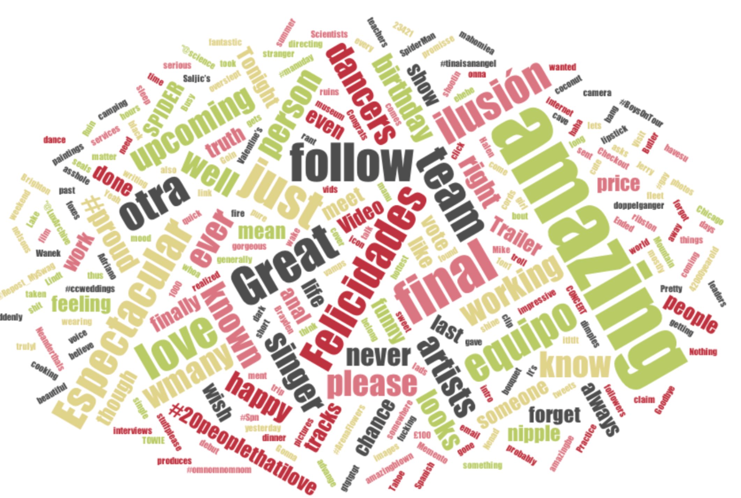

# Design Sketch

We will be using the following sort of layout for our site:

